
RAMAIAH
INSTITUTE OF TECHNOLOGY
USN | 1 | M | S

(Autonomous Institute, Affiliated to VTU)
Bangalore – 560 054

SUPPLEMENTARY SEMESTER EXAMINATIONS – AUGUST 2017

Course & Branch | : | B.E : Information Science and Engineering | Semester | : | IV
Subject | : | Finite Automata and Formal Languages | Max. Marks | : | 100
Subject Code | : | IS416 | Duration | : | 3 Hrs

Instructions to the Candidates:
- Answer one full question from each unit.

 |  | UNIT - I
1. | a) | Define the language of NFA. Prove that “If D=(Q_{D}, Σ, δ_{D}, {q0}, F_{D}) is the DFA constructed from NFA N=(Q_{N}, Σ, δ_{N}, q0, F_{N}) by subset construction, then L(D)=L(N)” | CO1 | (10)
 | b) | Define DFA. Construct DFA recognizing the following languages over the alphabet {a, b}  - L={ab}* U {a}  - L={w | w begin with ‘a’ but does not contain ‘aab’ as a substring}  - L={w | w ends with either ‘ab’ or ‘ba’ } | CO1 | (10)
2. | a) | Discuss in detail, the central concepts of automata theory. | CO1 | (10)
 | b) | Define є-closure. Consider the following є-NFA:  - Compute the є-closure of each state.  - Convert the automaton to a DFA. | CO1 | (10)
   | є | a | b | c
  - P  q  *r | Ф  {p}  {q} | {p}  {q}  {r} | {q}  {r}  Ф | {r}  Ф  {p}
 |  | UNIT - II
3. | a) | State and prove pumping lemma for regular languages. Show that the language L = {WW^{R} | W є {a, b}*} is not regular. | CO2 | (10)
 | b) | Give a regular expression E that expresses the set of strings recognized by the following DFA:  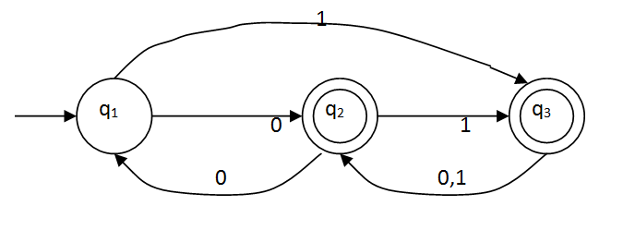 | CO2 | (10)
4. | a) | Prove that “If L and M are regular languages, then so is L∩M”. | CO2 | (10)
 | b) | Discuss the steps to construct minimum automaton using Table filling algorithm and apply the same to minimize the following automaton: | CO2 | (10)
   | 0 | 1
  - A  B  C  D  *E | B  C  D  C  B | C  E  C  E  E
 |  | UNIT - III
5. | a) | Describe the language of the following CFGs as concisely as possible:  - S->aSa|A, A->bAb|ε  - S->AB, A->aA|ε , B->Bb|ε | CO3 | (04)
 | b) | State and prove pumping lemma for the CFLs. | CO3 | (07)
 | c) | Convert the following grammar into CNF:  S->ABC|Bab  A->aA|BaC|aaa  B->bBb|a|D  C->CA|AC  D->ε | CO3 | (09)
6. | a) | Define inherently-ambiguous grammar. Show that the following grammar is ambiguous S → a S| X , X → a X | a | CO3 | (06)
 | b) | What are useless symbols? Write the procedures to identify useless symbols in the CFG. | CO3 | (06)
 | c) | Convert the following grammar into GNF: S->AA|0, A->SS|1 | CO3 | (08)
 |  | UNIT - IV
7. | a) | Define language of PDA by final state and by empty stack. Design a PDA for the language L= {w|w ∈ (a,b)* and n_{a}(w)>n_{b}(w)} | CO4 | (10)
 | b) | Convert the grammar:  S→ aABC  A→aB| a  B→bA|b  C→ a  To a PDA that accepts the same language by empty stack. | CO4 | (10)
8. | a) | Define DPDA. Prove that if L is a CFL and R is a regular language, then L ∩ R is a CFL. | CO4 | (10)
 | b) | Convert the give PDA to CFG.  - δ (q0,a,Z)=(q0,AZ)  - δ (q0,a,A)={q0,A}  - δ (q0,b,A)={q1, ɛ }  - δ (q1,ɛ,Z)={q2, ɛ } | CO4 | (10)
 |  | UNIT - V
9. | a) | Construct a turing machine which accepts the language L= {0^{n}1^{n+1}|n>=1}.  i) Write the transition diagram.  ii) Show the sequence of Instantaneous Descriptions(IDs) for the input  string 00111. | CO5 | (13)
 | b) | Prove the statement: Every language accepted by a multitape TM is recursively enumerable. | CO5 | (07)
10. | a) | Write a short note on working of multiple tracks TMs. | CO5 | (06)
 | b) | Construct a turing machine which accepts the language L= {a^{n}b^{n}c^{n}|n>=1}.  i) Write the transition diagram.  ii) Show the sequence of Instantaneous Descriptions(IDs) for the input  string aabbcc. | CO5 | (14)
****************

